RESUME
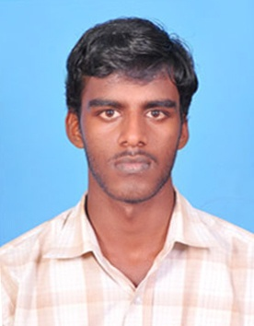

I.RAJESH
No -170,South Annai Karai street,
Sokkanathan Pet.
Puducherry-605 009.
Mobile no-9092253562.
sivarajesh221188@gmail.com

Objective

To achieve the highest standards in my work through innovation and dedication and simultaneously contribute to the growth and success of my organization.

Educational Profile

Degree/Course | Percentage | Year of Passing | University/School
B.SC(CS) | 69% | 2012-2015 | Thiruvalluvar university
High school | 55% | 2008 | Immaculate heart of Mary’s high school, Puducherry-10

Computer Skills

Programming languages : DCST,DCHT,Multimedia Animation & WebDesigns
Application Tools : MS Office

Additional Qualification

Certified Cours : 3DSMax, adobe premier pro, Photoshop, Flash

Experience

Company : KLICKSKILL pvt.ltd.
Designation : Graphical Designer
Duration : From 2010 to 2012
Experience : 1 and half years

Company : Emantras Interactive Technologies pvt.ltd.
Designation : Graphical Designer
Duration : From 2015 to 2016
Experience : 1 years

Project Experiences
Cisco
Oracle
E-leaning in - Flash
IT projects

Royal Enfield

BISK

Area of Interest

- Designing
- Maintaining
- Developing
- Programming

Personal Profile

Name : Rajesh.I
Father’s Name : Iyyaner.S
Date of Birth : 22.11.1991
Sex and Marital Status : Male & Single
Nationality : Indian
Religion : Hindu
Languages Known : Tamil and English

Declaration

I here by declare that all the above mentioned facts are true to the best of my knowledge.

Place: Puducherry
Date: I.RAJESH

